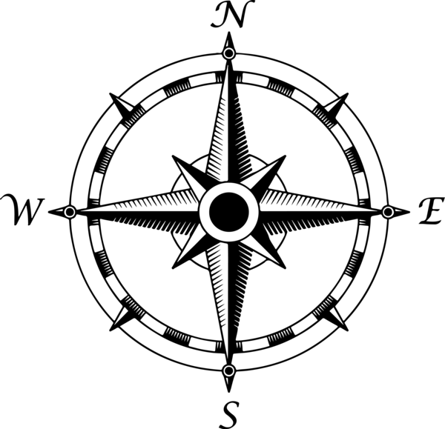

11th Grade Project Management Plan

Name of Project

Group Members

Idea #1
Describe your approach for one of your 3 plausible ideas.

Resources
List what materials, funding, or human resources are needed to implement this idea. Include specific details such as deadlines and contact info.

Tasks
This could be called a “to do list”. List what actions are needed (emailing people, follow up phone calls, meetings organized, materials or info that needs to be gathered, etc.)

Delegate tasks
Break the above list down into parts and assign each task to a group member. Think this through, as some tasks are related to each other and should be completed by the same person. List each group member and what tasks they will do. when each task is complete, select and highlight.

